**2. Careful measurement of a celestial object’s position in the sky (astrometry) may be used to determine its distance**

***Define the terms parallax, parsec, light-year***

* **Parallax** is the apparent change in position of a nearby object relative to a distant background, due to a change in position of the observer.
  + In regard to astrophysics, parallax is evident in how the changing position of Earth causes celestial bodies to appear as if they’re changing position. This is because our perspective of celestial bodies relative to their background is constantly changing.
  + Parallax is usually quoted as an angle and is most commonly measured in arc seconds.
* One **parsec** (pc) is the distance from the Earth to a point in space that has an annual parallax of one arc second. For the purpose of comparison between various length units,

$$1 parsec=3.09×{10}^{13} kilometres=3.26 light-years$$

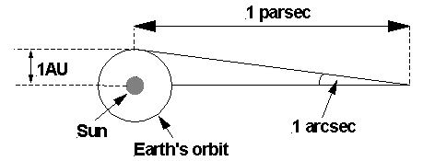

* One **light-year** is the distance travelled by light (or any other EM wave) through space in one year. For the purpose of comparison between various length units,

$$1 light-year=9.46×{10}^{12} kilometres=0.31 parsecs$$

***Explain how trigonometric parallax can be used to determine the distance to stars***

* Trigonometric parallax refers to the method of determining distance by using trigonometry and parallax.

Background

* Observations of a star during the course of a year will show apparent shifts in its position against the background of more distant stars. The largest shift will be between observations made six months apart.
* Consequently, we define the annual parallax (p) of a star to be half the angle through which the star appears to shift as the Earth moves from one side of its orbit to the other. It can be seen in the diagram below. This will be important, when we discuss what trigonometric parallax involves mathematically.

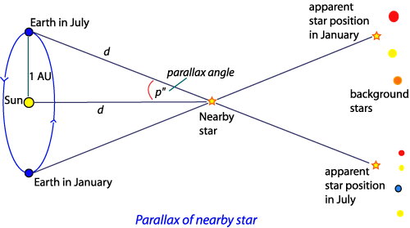

Mathematically

* So, above we have a right angled triangle. As a result, using trigonometry, we get:
  + - Note, even though technically incorrect, we label the distance of the star from both the Sun and Earth as $d$. This is because we are dealing with such small parallax angles, which means the difference between these two distances is insignificant, considering we’re dealing with stars that are light-years away.
    - Now, we’re going to use a mathematical assumption– when dealing with very small angles (i.e. angles very close to zero), we can assume $θ=\sin{θ}$
 $∴p=\frac{distance from Sun to Earth}{d}$

   - Now, the distance from the Sun to the Earth is defined as 1 astronomical unit (AU). Therefore, subbing it in …
 $∴p=\frac{1}{d}$

   - And if we rearrange, we get …
$d=\frac{1}{p}$

* As a result, we can see that the distance of a star from Earth is inversely proportional to parallax. The greater a star’s annual parallax, the closer it must be to us, and vice versa.

***Discuss the limitations of trigonometric parallax measurements***

* The more distant the star, the smaller the parallax angle. However, beyond a certain distance, it becomes impossible for our best telescopes on Earth to accurate measure parallax. This means that the trigonometric parallax method is only useful for measuring distance to stars that are relatively close.
* In fact, considering the effects of atmospheric distortion, measuring parallax angles less than 0.01”, when using ground-based astronomy, has great inaccuracy. This means that accurate trigonometric parallax measurements, when using ground-based telescopes, are limited to around 100 parsecs. This then limits the use of trigonometric parallax via ground-based astronomy to the closest 700—1000 stars.

***Solve problems and analyse information to calculate the distance to a star given its trigonometric parallax using: $d=\frac{1}{p}$***

* Okay, so here’s the formula again: $d=\frac{1}{p}$, with
  + d is the distance of the star from Earth, in parsecs (pc)
  + p is the annual parallax of the star, in arc seconds (arcsec)
* *Example Q* 🡺
  + **Question** 🡪 Calculate the distance (in both parsecs and light-years) of Procyon from Earth, if Procyon has an annual parallax of 0.286 arc seconds. Give both answers to 3 decimal places.
  + **Solution** 🡪
    - and $d=3.497×3.26 light-years$

$d=11.400 light-years (to 3 d.p.)$

***Gather and process information to determine the relative limits to trigonometric parallax distance determinations using recent ground-based and space-based telescopes***

* From ground-based observatories, the smallest parallax angle that can be measured is around 0.03 arc seconds. The distance to a star with a parallax 0.03 arc seconds is:
$d=\frac{1}{p}$

$d=\frac{1}{0.03}$

$d≈33 parsecs≈108 light-years$

* However, our galaxy is about 130 000 light years in diameter. Thus, the distance of 108 light-years, as the maximum distance that can be accurately measured using ground-based astronomy, is too small.
* Much better results are possible from space, where we can avoid the effects of atmospheric distortion. Thus, there are a number of orbiting satellites, gathering data for trigonometric parallax measurements.
* For example, the Hipparcos satellite can accurate measure parallax angles as small as 0.001 arc econds. A star with this parallax will be at a distance of:
$d=\frac{1}{p}$

$d=\frac{1}{0.001}$

$d=1 000 parsecs≈more than 3 000 light-years$

* This has increased the range of accurate distance measurements, with Hipparcos mapping 100 000 stars to a precision 100 times better than before and measuring the approximate distance to 2 million stars.
* Construction is underway on a space observatory Gaia to be launched soon. Gaia is basically a technological update of the Hipparcos system, and will be capable of measuring parallax angles as small as 0.00002 arc seconds. As a result, Gaia will be able to accurately locate stars at a distance of:
$d=\frac{1}{p}$

$d=\frac{1}{0.00002}$

$d=50 000 parsecs≈more than 150 000 light-years$

* This will allow Gaia to accurately map our entire galaxy, although the plan currently is to ‘only’ map 1 billion stars in our galaxy, the Milky Way.